Presidents report FMR AGM 31/8/2014
Firstly, thanks the David and Kate for the hosting of the meeting at their property at Tomboye.
After completing two major projects over the last few years (Macquarie perch project; the Bank Job), 2013/14 has been a relatively quiet period for FMR, allowing people to relax and recharge their batteries. However, we cannot totally relax and must keep a watching brief on environmental issues at both national, State and local levels. The activities of the NSW state government, the Abbott-oir federal government and activities in the Palerang Council have seen a number of premature fatalities, butcherings and suggestions of things to come for a range of environmental programs and issues including:
- The repeal of the federal carbon tax
- The stated opinion of Prime Minister Abbott that we have ‘too many national parks’
- The ‘independent’ report on the future of the Renewable Energy Targets (by an avowed climate change sceptic) suggesting the scheme should dramatically scaled back or closed
- The abolition of the national Climate Commission
- The increasing centralisation of NSW government planning processes
- The move at state and federal levels to ‘cut green tape’
- The failure of the Abbott Government to appoint a Minister for Science.
- The backflip on environmental zonings in the Palerang LEP
FMR must continue to be vigilant about threats to the river and its biodiversity, with the recent clearing of trees along Northangera Road an example.
It has not been a particularly quiet year for the river itself, with a number of high flow events that have likely invigorated ecological processes within the river, and forming a stark contrast to the prolonged drought of the 2000’s. You can see from the graph below how the amount and variability in flow has changed since the drought broke in late 2010.
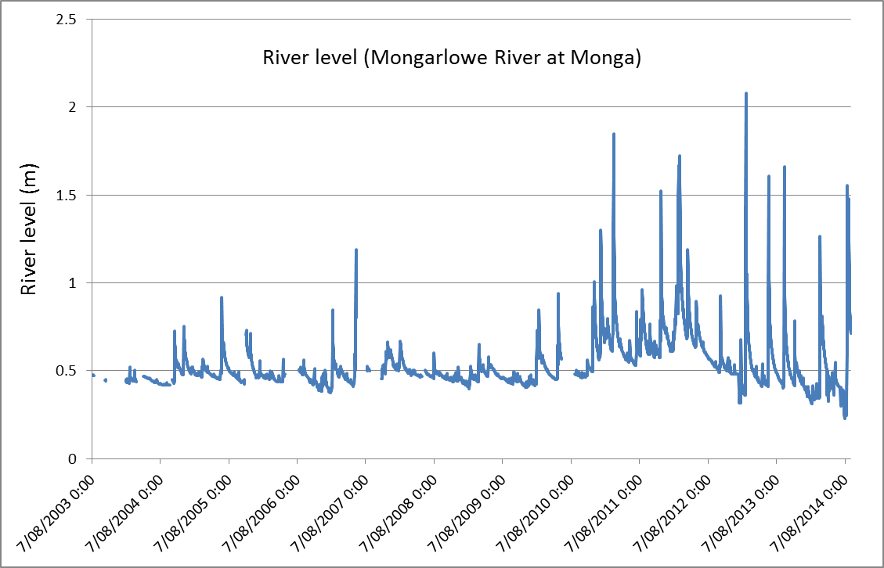

FMR activities in 2013/14 have included additional tree planting and site inspections at the Bank Job (on the Riverlea property), with a proposed Macquarie perch netting to monitor fish abundance at the site postponed as a result of high water. We will try again in the coming autumn. Thanks also to the new lessees of the Riverlea site Neale and Jo for their willingness to continue to allow access to the property, and their interest in the project.
After a quiet 2013/14, I hope that we can become a bit more active in 2014/15, both with a social as well as environmental focus. A range of potential activities are worth thinking about including;
- Developing a more formal monitoring approach to the bank Job (see minutes of FMR general meeting of 31/8/2014)
- A downriver canoe trip to look at potential changes since the last downriver escapade of 2008
- Some fauna and vegetation activities to increase knowledge and appreciation of the natural resources of the Mongarlowe catchment
I would like to thank the FMR committee and office-holders for their continued enthusiasm for the group, and for their assistance to me over the past 12 months, and hope that 2014/15 will be a productive and exciting year for FMR.

Mark Lintermans
1/9/2014

